EDN110

Reflective Journal

Shelley Rogers

31820955

For my reflective journal I will be discussing the topics of Fractions and Algebra. These two topics bring back bad memories from my own schooling and I could not understand why this is part of the curriculum for school students. I was under the impression that I did not use these topics in my day-to-day living. However after having completed the topics I now understand that I do use this knowledge, I just don’t realise it. After talking to family/friends/peers, these two topics have a lot of negativity attached to them, however I now believe it is all related to how they were taught when they were at school. My own views on the two topics have changed dramatically since beginning this unit.
FRACTIONS
PROBLEM
When our lecturer told us we had to learn how to add, subtract, multiply and divide fractions, I got really concerned. I was thinking how on earth am I going to learn that and be confident enough to teach my future students? I remember my own teachers when I was at school, they were not enthusiastic and really didn’t seem to care about the topic. None of my classmates took a lot of interest in the subject and therefore created negativity toward the topic. That negativity has stayed with me since then and as soon as I learnt that I was to revisit the topic, all I had was negative thoughts.
HOW I DEALT WITH THE PROBLEM
My first problem was a personal one; I had to teach myself to not have a negative reaction to the topic. After I read the lecture notes online, I decided that I would research the meaning of the word fraction. I thought that by doing this I would have a basis of which to go from. ‘Fraction - A part of a whole quantity or number’ (Klerk 2002). Having a very basic idea of the concept behind fractions, I was able to approach the topic with new found enthusiasm and no negativity. I understood the purpose of fractions.
Adding and subtracting fractions became a lot easier once Kai Fai Ho, explained to us common denominators. A denominator is ‘the bottom number in a fraction’ (Haylock 2010). So to make a common denominator, I would have to find a number that was a multiple of both denominators. Once I had done this I would then adjust the numerator ‘the top number in a fraction’ (Haylock 2010), by multiplying by the same sum. Let me explain this in table 1.
As both 2 and 3 are multiples of 6, I will change both the denominators to 6 and adjust the numerator accordingly.

Or as a subtraction

Table 1
Multiplication and division were explained really well. The most important part of the whole exercise was my times tables. I am so thankful that they were drilled in to me over and over again. We would have to do our times tables every day when I was in primary school and I am so thankful to that now. Without my times tables I would have relied heavily on my calculator and there is a sense of personal satisfaction when you are able to tackle some maths problems mentally.
When multiplying fractions all you have to do is multiply the numerators together and then multiply the denominators together. I have done an example in table 2
Table 2
Dividing fractions has a slight twist – but nothing too hard, flip the second fraction upside down so the denominator becomes the numerator and the numerator and becomes the denominator then multiply the fraction as you would in a multiplication. I have given an example in table 3.

Table 3
In this example the numerator is larger than the denominator resulting in an improper fraction ‘ a fraction whose numerator is greater than its denominator’(Klerk 2002) ; therefore I must simplify the fraction. ‘Simplify – make simple. Write in the shortest, simplest form’ (Klerk 2002) See table 4
Table 4
By simplifying the fraction I now have a mixed number ‘A whole number and a fraction’ (Klerk 2002)
One way in which I have gained confidence in my problem solving is by ‘teaching’ my peers in our tutorial how I arrived at the answer. Kai Fai Ho allows us to explain our answers and write on the whiteboard just like we would if we were teaching students. I have gained some confidence in doing this as we are encouraged and if the answer is wrong we are shown the correct way to get to the answer.
POSSIBLE IMPLICATIONS FOR TEACHING
I think some possible implications for teaching fractions could be that I will have to physically write down the fraction number sentence to work out the answer. However, this could serve as a positive for my future students as they will be able to see more examples shown to them and that even adults have to write out the equation to get the answer. By seeing that I have to write the problem out, it could boost their confidence. Another possible implication is if the students are not confident or competent in their times tables. As I have already stated I needed to have this skill for working out how to multiply and divide fractions. If the students are not skilled in times tables they will have a disadvantage and lack confidence, this could result negatively and put up ‘road blocks’ for their learning. Kai Fai Ho also said that it would be handy to know several ways of explaining the same problem. See table 5.
Table 5
As Kai Fai stated, some people need different ways of being shown a problem for them to understand how to work out the solution. I think that if I stick to only showing one example of problem solving, I will not get very far with my future students and they will not learn very much. Children need variety in their day and get bored very quickly, therefore having different skills to teach them I hopefully, will be able to combat this.
Equivalent fractions could be another implication for children if they cannot see the relationship between the numbers. ‘Equivalent fractions: two or more fractions that represent the same part of a unit of the same ratio. For example, 2/3, 4/6, 6/9, 8/12 are all equivalent fractions.’ (Haylock 2010) To combat this problem I think having a fraction wall will help, as it shows the relationship between fractions 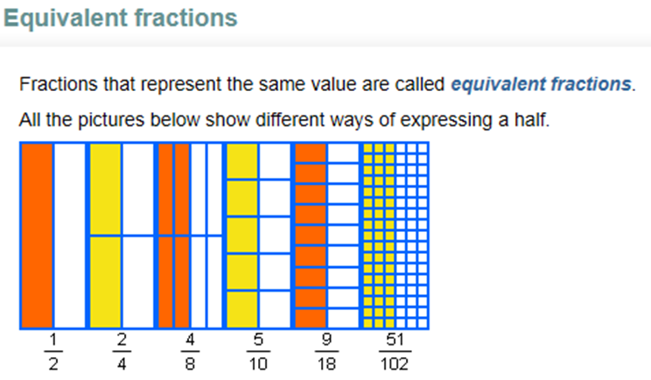
(Zealand 2011)
POSSIBLE IMPLICATIONS FOR LEARNING
I think some possible implications for learning fractions could be fear of being made fun of by peers or getting the answer wrong. If a student has these fears they are not going to want to participate in activities and they will lose confidence. Another possible implication could not knowing the basics of mathematics – that is times tables. If a student doesn’t know this they will find it hard to do the problems. I witnessed this in my tutorial as a number of peers did not know their times tables and found it hard to do the problems.
In the student workbook (Haylock and Manning 2010) task 110 it asks;
How would you respond to a child who draws these diagrams and concludes that 4/6 and 3/4 are equal?
I would respond to this situation by explaining that they look the same because the portions are different sizes in diagram A, so it is misleading. I would draw an example to show the student the correct answer -
when the circles are divided equally it is easy to see 3/4 is more than 4/6.
RECOURCES
There are so many amazing resources available to help in the teaching and learning of fractions that I wanted to have a section just on that. Ron Smith, has two fantastic books that I have used to practise fractions and have also made copies for when I am teaching the subject to my future students (Smith 2007; Smith 2007) It is age appropriate 6-9 and 8-12 which will be helpful in lesson planning for the appropriate ages. One activity that I find great is on p 74-75 in the age 8-12. I have found Illustrated Maths Dictionary very useful in helping me understand meanings of the mathematic terms. I think this could be extremely useful for students as it gives a simple explanation of the terms used in maths. Mathematics Explained for primary teachers has been very helpful as I have been able to read the chapters and get an overview of the topics we have been learning, I also find the questions at the end of each chapter very helpful.
HOTmaths has been the most helpful of all the resources in this topic. I think it has been so helpful because it is interactive and we are very much a computer-based society and HOTmaths is online. A positive aspect of HOTmaths is the students can work through the problems at home at their own pace and they won’t get ridiculed or teased if they get the problem wrong. We have been given examples from NAPLAN, however I am questioning whether I like this as there is nowhere to check the answers. I don’t think this would be very helpful to students as they need to know if they solved the problem correctly to see if they have the understanding of the formula required.

ALGEBRA
PROBLEM
I could not understand why algebra was important and how it applied to everyday life. I had told myself that it was unimportant and therefore I had turned myself off from learning, no matter what anyone said. How is it possible for letters to represent numbers? How is it possible to work out what that letter stands for? If an adult is stuck on this topic, how is it possible for children to make sense of it?
HOW I DEALT WITH THE PROBLEM
I had to do the same with algebra as I did with fractions, that is consciously pay attention and make sure I didn’t slip into old habits and ‘tune out’. I thought I would start by researching the term algebra. ‘Part of mathematics that studies number systems and number properties. In algebra we use numerals, symbols or letter, called pronumerals or vairables, to stand for the unknown values. Examples
☼ + ☼ =2☼
5-X
a+b+c
x²-2xy+y’ (Klerk 2002)
I also looked up what a variable was so I could get a better understanding of when or why we would need an algebra equation, or as Kai Fai Ho was referring in our tutorial algebraic thinking. ‘Variable – (i) A symbol or letter representing an unknown number of a set. In algebraic expressions, a variable stands for a value. Sometimes it is called an unknown. Example:
In x² +3x+2 = 0, x is the variable.
(ii) The same variable may have different values under different conditions. Example:
x+3=5 x = 2
x-1=10 x = 11
(iii) A mathematical sentence that has at least one variable is called an open sentence. Example:
x + 3 = 7 is true only when x = 4
The number 4 is called the solution of x + 3 = 7
If x is replaced by any other number, the sentence will become not true (False). (Klerk 2002)
Kai Fai Ho told us that arithmetic = numbers and generalised arithmetic = algebra.
From the lecture I learnt that skip counting is the first introduction to algebra as it looks at 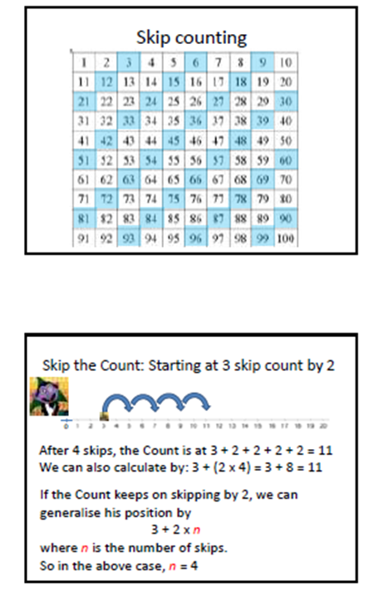number patterns (Ho 2012)
In the lecture we did an activity to find number patterns on a number wall (as seen in the skip counting diagrams). Take 3 numbers horizontally next to each other 26 27 28 ( N N+1 N+2 ). If we were to add this using arithmetic it would look like this – 27= 26 + 28 / 2
If we were to write this using generalised arithmetic it would look like this -
S = N + (N+2) / 2
We write this using letters to generalise the equation therefore we can apply it to any horizontal number sequence on the number wall. If we were to write a vertical equation we would only have to slightly change the generalised arithmetic –
59 N
69 N+10
79 N+20
S = N+ (N+20) / 2

POSSIBLE IMPLICATIONS FOR TEACHING
I think possible implications for teaching algebra could be if I do as my teachers did and speak with no enthusiasm and boredom in my voice. I would like to follow in Kai Fai Ho’s footsteps and explain it thoroughly and with passion. I hope that by using interactive teaching methods – for example HOTmaths (Zealand 2011), Leaning Federation (Limited 2011) – and by starting with skip counting that my future students will get a solid foundation and not have negative thoughts associated with the topic.
POSSIBLE IMPLICATIONS FOR LEARNING
If a student gets a negative attitude toward the topic, it will be very difficult for me as a teacher to get them to understand the formula/s in algebra. I think by showing enthusiasm and taking small steps, students are able to get a better feel for the topic. As there is so much technology available and children being so computer smart, I think that if I use that to my advantage and teach using technology, my students will engage better and learn more. As I have stated in Fractions, the more variety in teaching methods – the higher possibility of the students learning.
Ridicule and getting the answer wrong will be very disheartening for children and teachers need to be very careful when a student gets the answer wrong. If students are able to practice the topics at home before group participation, there is a higher change of all students being involved in the discussion.
RECOURCES
As with fractions, there are so many fantastic resources available to help in the learning and teaching of algebra. The unit textbook Mathematics Explained for primary teachers (Haylock 2010) is very good and also has questions at the end of the chapter to help practise the skills taught in the text. I found some great question sheets in Cognitive Connections (Myers 1997) on pages 96 – 101, although it took me a while, I was able to work out the solution and check it with the answers in the back of the book. This book would be a fantastic resource as it engages students and gets them to work out the solution. If you are wanting to use technology to teach this unit, HOTmaths (Zealand 2011) is great, as is the Learning Federation (Limited 2011). The only negative I have towards these websites is you need a login and it depends on the school if the students have access to this.
CONCLUSION
Fractions and Algebra have a lot of negativity attached to them. Because of this students and teachers alike, find these very difficult topics to master. I had to make a conscious effort to not allow my past experience to interfere with my learning of the topic now. I have learnt that both the topics aren’t as daunting as I remembered; it was just the way they were delivered to the students. My lecturers show a lot of enthusiasm in teaching the topics and the interaction in the classes and online are an enormous help in the learning process. I hope that when I am teaching I will have the passion and understand of the topic that I was shown and also the technology/recourses that I have available at University.
REFERENCES

Haylock, D. (2010). Mathematics Explained for primary teachers. London, SAGE Publications.
Haylock, D. and R. Manning (2010). Mathematics Explained for primary teachers. London, SAGE Publishing.
Ho, K. F. (2012). S. Rogers. Rockingham.
Klerk, J. d. (2002). Illustrated Maths Dictionary. Illustrated Maths Dictionary. C. D. a. T. Fullerton. Malaysia, KVP, Pearson Education Australia: p:54.
Limited, E. S. A. (2011). Retrieved 1 April 2012, 2012, from http://econtent.thelearningfederation.edu.au/ec/p/home.
Myers, R. E. (1997). Cheltenham, Victoria, Hawker Brownlow Education.
Smith, R. (2007). Cornerstones in Numbers. Carlton South, Victoria, Curriculum Corporation.
Smith, R. (2007). Cornerstones in Numbers. Carlton South, Victoria, Curriculum Corporation.
Zealand, C. U. P. A. a. N. (2011). "HOTmaths." Retrieved 1 April, 2012, from http://www.hotmaths.com.au/.

